**Q1.**

**A company has an API to manage purchase orders, with each record identified by a unique purchase order ID. The API was built with RAML according to MuleSoft best practices.**

**What URI should a web client use to request order P05555?**

A/orders/{P05555}

**Q2.**

**A Database On Table Row listener retrieves data from a CUSTOMER table that contains a primary key userjd column and an increasing kxjin_date_time column. Neither column allows duplicate values.**

**How should the listener be configured so it retrieves each row at most one time?**

BSet the target value to the last retrieved login_date_time value

**Q3.**

**Refer to the exhibits.**

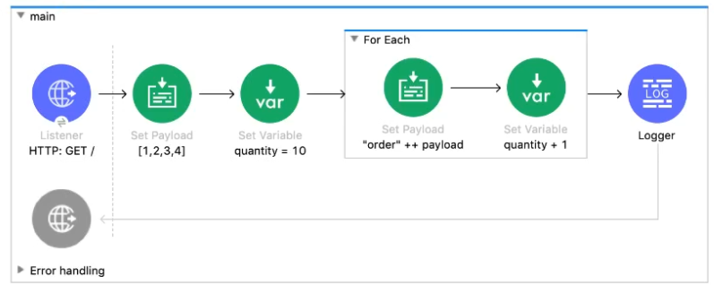

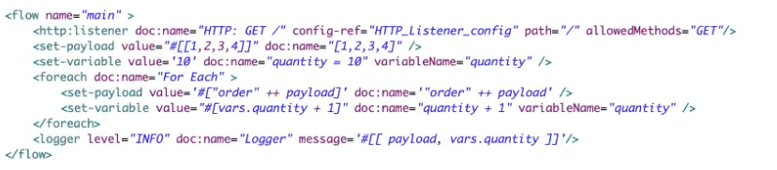

B[[order1, order2, order3, order4], 14]

**Q4.**

**A Mule project contains a DataWeave module called MyModule.dwl that defines a function named formatString. The module is located in the project's src/main/resources/modules folder.**

**What is the correct way in DataWeave code to import MyModule using a wildcard and then call the module's formatString function?**

AOption A

**Q5.**

**Refer to the exhibits.**

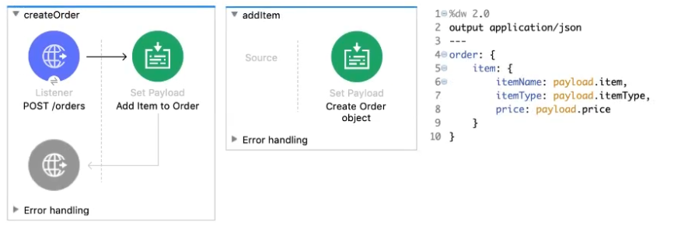

**The Set Payload transformer In the addltem subflow uses DataWeave to create an order object.**

**What is the correct DataWeave code for the Set Payload transformer in the createOrder flow to use the addltem subflow to add a router cable with the price of 100 to the order?**

Blookupf 'addltem', { payload: { price: '100', item: 'router', itemType: 'cable' } } )

What condition requires using a CloudHub Dedicated Load Balancer?

**B**When custom DNS names are required for API implementations deployed to customer-hosted Mule runtimes

Question 2

When designing an upstream API and its implementation, the development team has been advised to not set timeouts when invoking downstream API. Because the downstream API has no SLA that can be relied upon. This is the only donwstream API dependency of that upstream API. Assume the downstream API runs uninterrupted without crashing. What is the impact of this advice?

**C** A default timeout of 500 ms will automatically be applied by the Mule runtime in which the upstream API implementation executes.

Question 3

An API has been updated in Anypoint Exchange by its API producer from version 3.1.1 to 3.2.0 following accepted semantic versioning practices and the changes have been communicated via the API's public portal. The API endpoint does NOT change in the new version. How should the developer of an API client respond to this change?

**D** The API client code ONLY needs to be changed if it needs to take advantage of new features.

Question 4

A new upstream API Is being designed to offer an SLA of 500 ms median and 800 ms maximum (99th percentile) response time. The corresponding API implementation needs to sequentially invoke 3 downstream APIs of very similar complexity. The first of these downstream APIs offers the following SLA for its response time: median: 100 ms, 80th percentile: 500 ms, 95th percentile: 1000 ms. If possible, how can a timeout be set in the upstream API for the invocation of the first downstream API to meet the new upstream API's desired SLA?

**A** Set a timeout of 100 ms; that leaves 400 ms for the other two downstream APIs to complete

Question 5

An organization has several APIs that accept JSON data over HTTP POST. The APIs are all publicly available and are associated with several mobile applications and web applications. The organization does NOT want to use any authentication or compliance policies for these APIs, but at the same time, is worried that some bad actor could send payloads that could somehow compromise the applications or servers running the API implementations. What out-of-the-box Anypoint Platform policy can address exposure to this threat?

* **D**Apply a JSON threat protection policy to all APIs to detect potential threat vectors

Question 6

An organization is implementing a Quote of the Day API that caches today's quote. What scenario can use the CloudHub Object Store connector to persist the cache's state?

**A** When there is one deployment of the API implementation to CloudHub and another one to customer hosted mule runtime that must share the cache state.

Question 7

An organization is evaluating using the CloudHub shared Load Balancer (SLB) vs creating a CloudHub dedicated load balancer (DLB). They are evaluating how this choice affects the various types of certificates used by CloudHub deployed Mule applications, including MuleSoft-provided, customer-provided, or Mule application-provided certificates. What type of restrictions exist on the types of certificates for the service that can be exposed by the CloudHub Shared Load Balancer (SLB) to external web clients over the public internet?

**B**Only MuleSoft provided certificates can be used for server side certificate

Refer to the exhibit. What are the values of the counter and stepVar variables in the On Complete phase?

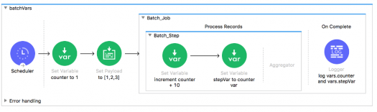



Counter: 1, stepVar: null

What MuleSoft product enables publishing, sharing, and searching of APIs?



Anypoint Exchange

Refer to the exhibit. What are the values of the counter and stepVar variables after the Batch Job?

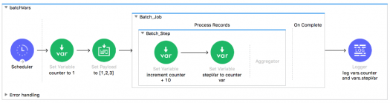



Counter: 1, stepVar: null

A Batch Job scope has three batch steps. An event processor in the second batch step throws an error because the input data is incomplete. What is the default behavior of the batch job after the error is thrown?



All processing of the batch job stops

Refer to the exhibits. What is the output of the Logger component in the Batch Job?

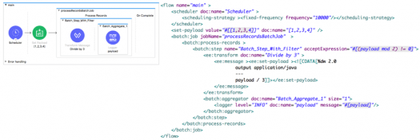

In a RAML specification, what attribute defines a query parameter to be optional for a resource?



Required: false

What is NOT part of a Mule 3 message?



Variables

What out-of-the-box policy can safeguard against Denial of Service type attacks?



Rate limiting

A Mule application properties file named training-DEVproperties has been defined. How is the properties file referenced in the Mule application?



In a Property Placeholder element

What port number is used to expose the domain URL of a Mule application deployed to CloudHub?



8081

What message processor can set the HTTP response status code to 200?



Set Payload

What property of a Mule message is immutable?



InboundProperties

A Mule application has two flows named parentFlow and childFlow. A variable is defined in parentFlow. What is true for a Mule subflow?

What is the default processing strategy of a one-way flow?



Queued-asynchronous

What is required for two Mule applications to share data using a VM connector component?



Put the Mule applications in the same non-default Mule domain

How are outbound properties automatically passed to an outbound REST request using an HTTP Request component?



As headers

A WSDL defines a conversionRate operation with an input message that requires two parts: fromCurrency and toCurrency. How are fromCurrency and toCurrency set in the flow in order to call the conversionRate operation using a Web Service Consumer component?



In the message payload

What is NOT a way to pass data to a RESTful web service in a flow using an outbound HTTP Request component?



Set inbound properties before the HTTP Request component

What asset can NOT be created using Anypoint Platform Design Center?



API portals

An exception is caught by a choice exception strategy. How is the exception routed?



To the first exception strategy whose condition evaluates to true

How is a default exception strategy set in a Mule application?



In a configuration global element in any Mule configuration XML file

A Payload filter is configured to test for type javalang_String. What happens when the filter is passed a message with the payload null?



All subsequent message processors are skipped

What module and operation will throw an exception if a Mule event's payload is not a number?



Validation module’s Is number operation

A Mule flow has a JMS queue listener as the message source. Where can the next message processor access a JMS messages header?



Inbound property

What part of a Mule flow can contain a Poll scope?



Message source

How is a Poll scope's watermark accessed from a message processor in a flow?



In a flow variable

A File connector configured to read files from a /mule/input directory. All other File connector settings are the default settings. What happens to a file after it is processed by the File connector?



The file is deleted from the input directory, but is not moved anywhere

What phase of a batch job using a Batch scope must contain at least one message processor?



Process Records

A message payload is modified using a Message Enricher scope with an empty target. What is true about the message payload that leaves the Message Enricher scope?



The payload returns to the original payload

A Batch scope has three batch steps. A message processor in the second batch step throws an exception because the input data is incomplete. What is the default behavior after the exception is thrown?



Stops processing the entire batch job

What is the purpose of the api:router element in APIkit?



Validates requests against RAML API specifications and routes them to API implementations

What is the scope of a record variable in a Batch scope?

A web client submits a GET request to a Mule 4 application to the endpoint /customers?id=48493. Where is the id stored in the Mule event by the HTTP Listener?



Attributes

Assume that a database table contains a record ID column that always increases as new records get added to the table. In a Mule application, what is the key process to enable manual watermarking for requests to a database using the Scheduler endpoint and the Database SELECT operation?

How is the success of a Center for enablement measured?



Measured on accessibility of assets

1. What are four ways APIs provide the info for how to communicate with a software component? (Select 4... lol)

This defines what you can call, what you send it, and what you get back:



Web Service

An API has been created in Design Center. What is the next step to make the API discoverable?



Publish the API to Anypoint Exchange

What is an application that controls access to a web service, restricting access and usage with an API gateway?



API Proxy

What is the actual implementation you can make calls to or the interface of that API implementation?

How are SOAP web services defined?



In an XML-based WSDL (Web Services Description Language) file

In what file does the Mule project keep track of all of its dependencies?



Pom.xml

What do RESTful web services use?



Existing HTTP communication protocol

What is the minimum required configuration in a flow for a Mule application to compile?



An event processor/A message processor in the Process section of a flow

What can ONLY be done with VM connectors, and NOT with Flow References, in a single Mule application?

Which RESTful web service request method partially updates a resource?



PATCH

Which RESTful web service request method creates a new resource?



PUT

An inbound Database connector is configured to select rows from a MySQL database. What is the format of results returned from the database query?

Which RESTful web service request method deletes a resource?



DELETE

What is NOT part of a Mule 4 event?



InboundProperties

What file type is required to configure a Web Service Consumer to consume a SOAP web service?



WSDL

How does APIkit determine the number of flows to generate from a RAML specification?



Creates a separate flow for each HTTP method

How are query parameters dynamically passed to an outbound REST request using an HTTP Request operation?

Where does a deployed flow designer application run in Anypoint Platform?

Clouhhub Worker.

What is the main purpose of flow designer in Design Center?

To design and Develop fully functional Mule applications in a hosted development environment

In the Database On Table Row operation, what does the Watermark column enable the On Table Row operation to do?

To avoid duplicate processing of records in a database

What is a core characteristic of the Modern API?

API is designed first using an API specification for rapid feedback

According to MuleSoft, what is the Center for Enablement's role in the new IT operating model?

Creates and manages assets to be consumed by of business developers

What statement is part of Mulesoft's description of an application network?

Create reusable APIs and assets designed to be consumed by other business units

What HTTP method in a RESTful web service is typically used to replace a resource completely?

PUT

What is the correct way to format the decimal 20.3844 as a string to two decimal places?

20.3844 as String {format: ".0#"}

What DataWeave 2.0 type can be used as input to a map operation?

Array

What MuleSoft API-led connectivity layer is intended to expose part of a backend database without business logic?

SYSTEM

How can an error scope be configured to catch all errors in the HTTP namespace?

Type: When: #[ error.errorType.namespace == "HTTP" ]

A Mule application has a flow named parentFlow. The parentFlow contains an HTTP Request operation at the end of the flow. The parentFlow also contains a Set Variable operation

right before the HTTP Request operation. What is the scope of the variable to the server receiving the HTTP Request from parentFlow?

The variable is NOT accessible in the server